**How to Flash XD75**

1、First connect your pcb to pc

2、use your tweezers touch two hole at the white box at the same time so that your PCB come into Bootloader mode

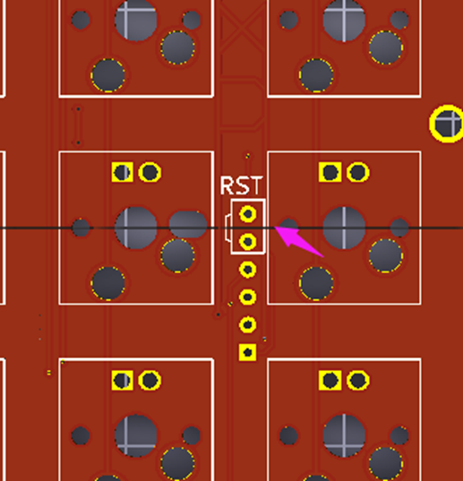

**3、Make sure you have install usb driver first.How to do?** Open **Zadig for Atmel DFU** , if the left Version is same with right in the red box , you don’t need install usb driver, if not, please click “install driver” to install USB driver.

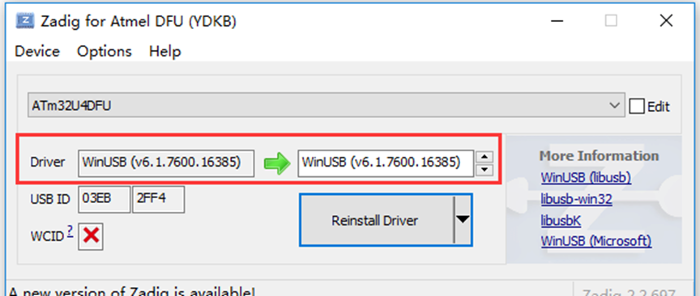

**4、**Open chrome in our document(we have install plugin well)

**Click this KLE link and you will see xd75 layout**

[http://www.keyboard-layout-editor.com/#/gists/ac341208e023e4a4d982bccf711ae38f](http://www.keyboard-layout-editor.com/" \l "/gists/ac341208e023e4a4d982bccf711ae38f)

Attention: if you want to edit this layout, just need select a key and then use your arrow key to move location/press right shift and arrow key to increase or decrease length/press Add Key is to add one blank keycap.

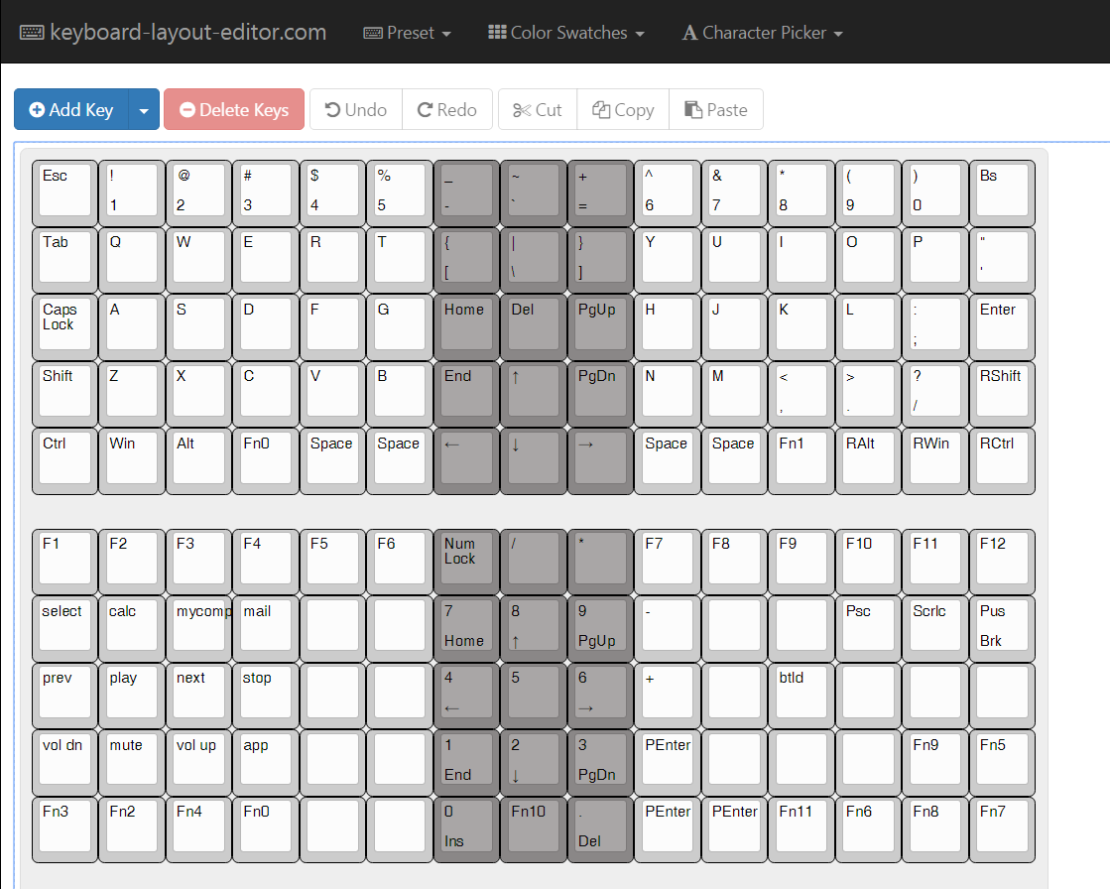

5、Input kai.tkg.io in our chrome browser：[http://kai.tkg.io/](http://yang.tkg.io/)

6、Do like the image below(you can copy and paste KLE layout url into composite layer,pls choose **XD75** in Config, the Fn and LED setting should be selected like the pic below)：

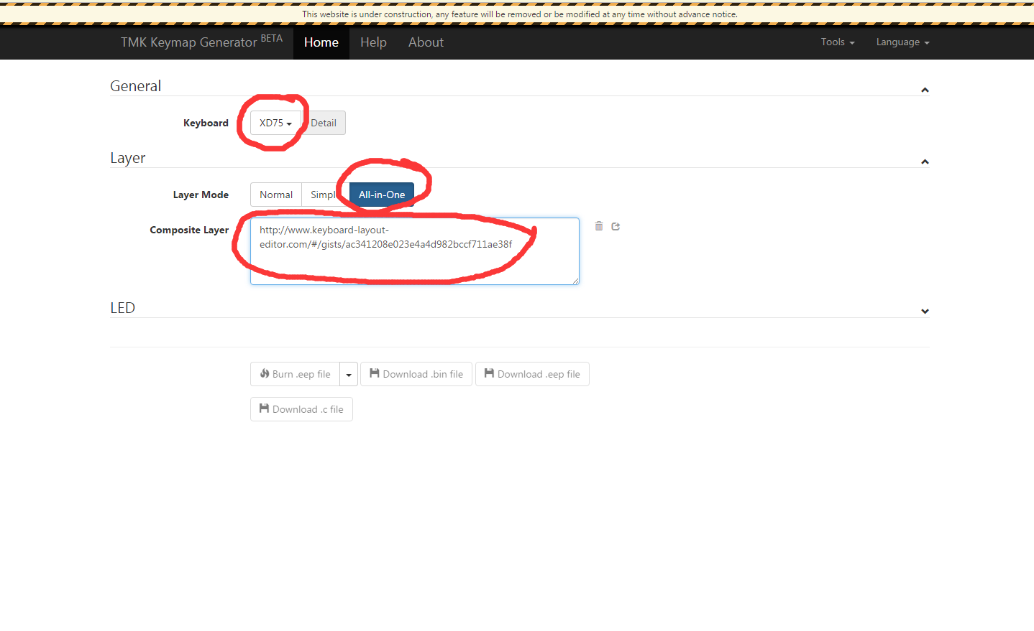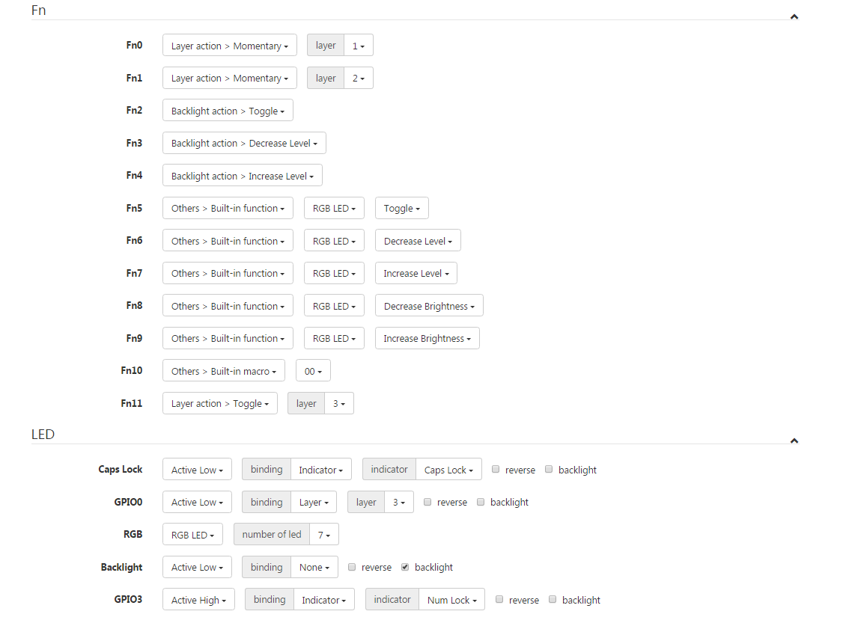

**If your LED options have no GPIO0/RGB/Backlight, please do like the following pic:**

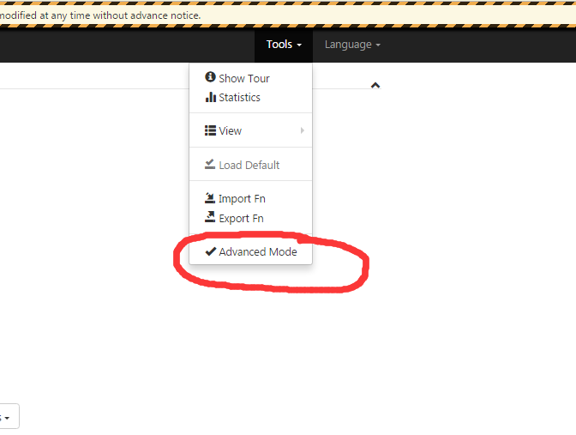

7、Then use your tweezers touch two hole at the white box at the same time so that your PCB come into Bootloader mode and the button”burn.eep” will becomes green color



8、then click burn.eep file



Waiting for about 5 sec and everything will be completed!